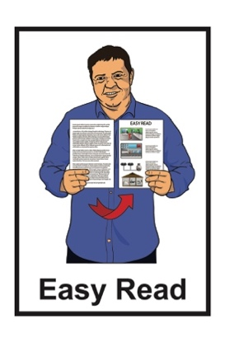

Review of the

Total Mobility scheme

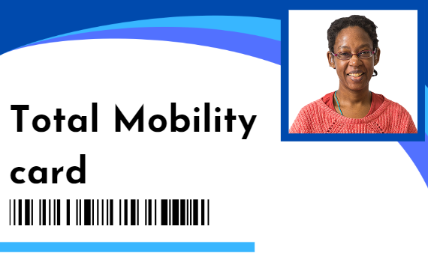

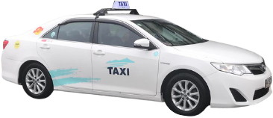
Published: November 2023

About the review

This Easy Read document is from Te Manatū Waka - Ministry of Transport which is the part of the Government that looks after transport.

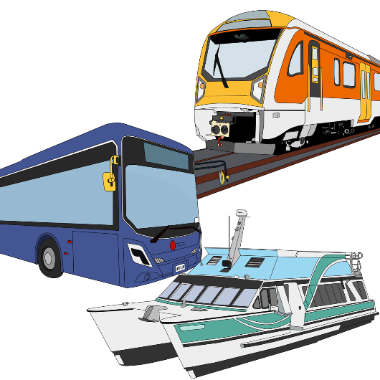
Transport means different ways of going places like:
taxis / rideshares like Uber
public transport like trains / buses
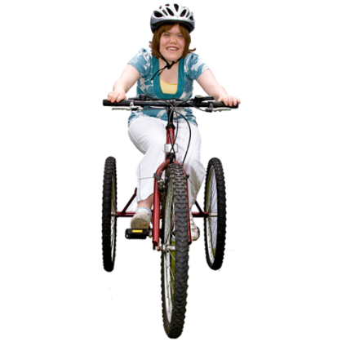
cars
bikes and scooters.

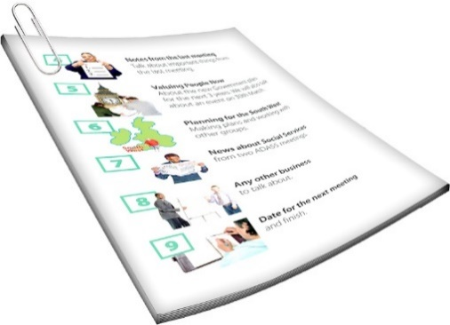
When we say we in this document we mean Te Manatū Waka - Ministry of Transport.
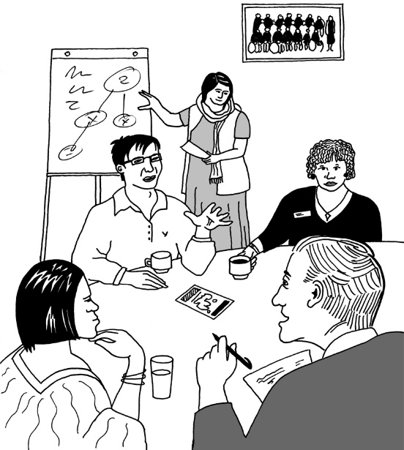
We are doing a review of the Total Mobility scheme.

A review is when we look at:
what things are like now
how things could be done better.

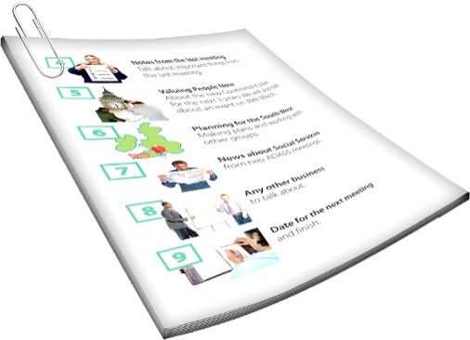
We will talk about what the Total Mobility scheme is in the next part of this document.

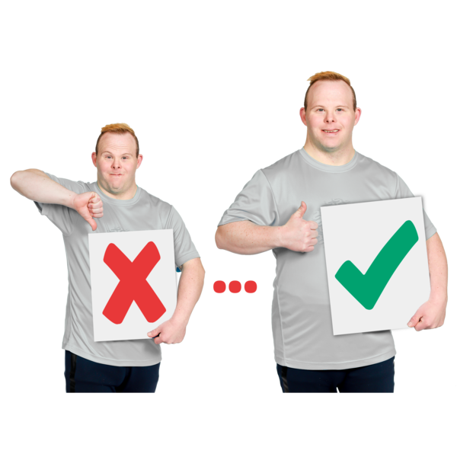
The review is to find out:
how the Total Mobility scheme is working
how it can be made better for disabled people.

The United Nations Convention on the Rights of Persons with Disabilities says that governments need to make sure disabled people have access to transport.

The United Nations Convention on the Rights of Persons with Disabilities is a law lots of countries have agreed to.

It says what governments must do to make sure disabled people get the same rights as everybody else.
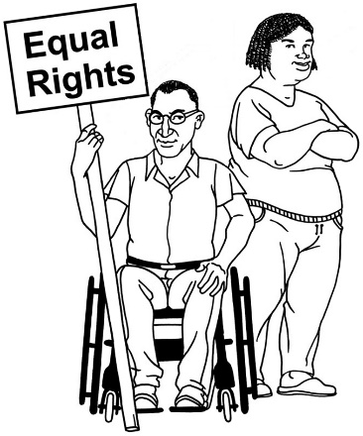

The review will be to make sure disabled people get the human rights set out in the United Nations Convention on the Rights of Persons with Disabilities.

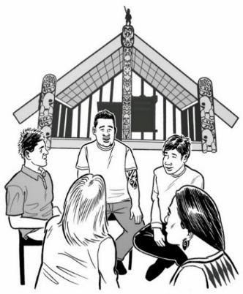
The review will be done in a way that:
fits the ideas in Te Tiriti o Waitangi
thinks about Māori ways of understanding disability.
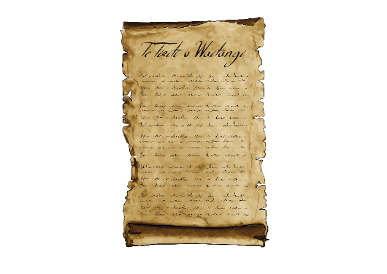

Te Tiriti o Waitangi / The Treaty of Waitangi is a legal document that was signed in 1840.

It is about Māori and the New Zealand Government:
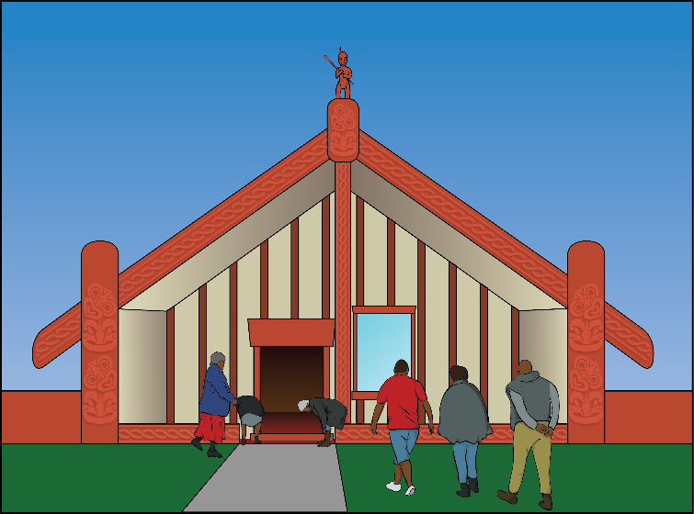
making decisions together
protecting things that are important to Māori.

What is the Total Mobility scheme?

The Total Mobility scheme is for disabled people who:
cannot safely travel on public transport like trains or buses
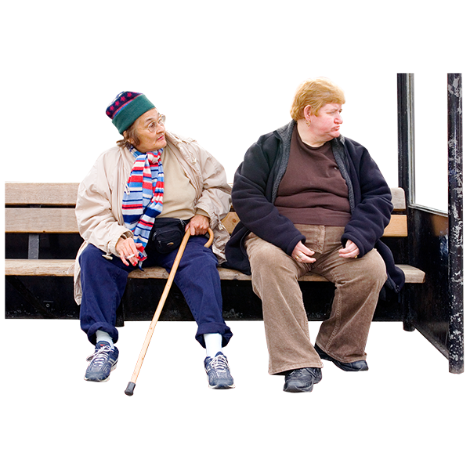
cannot get to where the public transport starts or ends because of their disability.

In this document we will also call the Total Mobility scheme Total Mobility.

People who can use Total Mobility get discounts on Total Mobility services.

A discount means you do not have to pay as much money.

Total Mobility services are things like:
taxis
community vans
companion driving services.

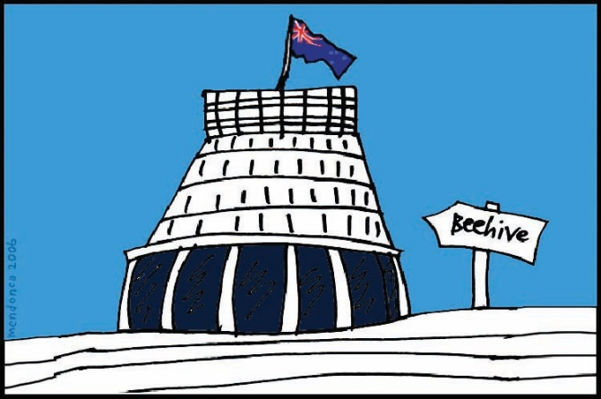
The rest of the cost of Total Mobility services is paid by:
the government
local councils.

People who use Total Mobility get the discounts by using:
Total Mobility cards
Total Mobility vouchers.

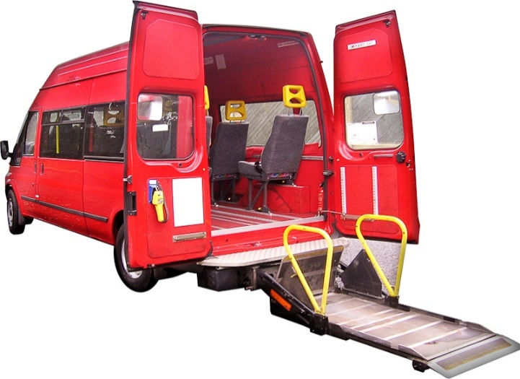
Total Mobility also pays part of the cost for wheelchair hoists in taxi vans.

A hoist lifts a person and their wheelchair into the taxi van.

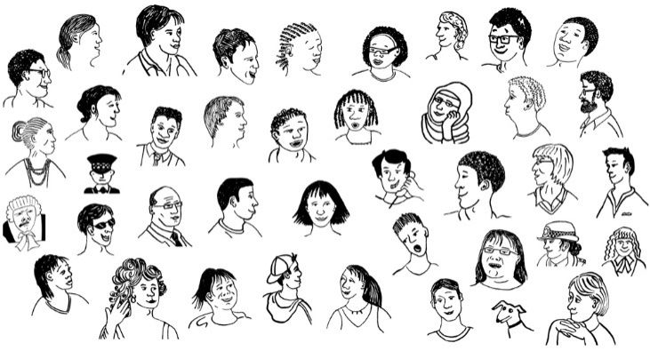
In 2022 – 2023 about 95 thousand people had Total Mobility cards / vouchers.

In 2022 more than 2 million trips were made using Total Mobility discounts.

What will the review look at?

The review will look at 4 main areas.

1. What is Total Mobility for?

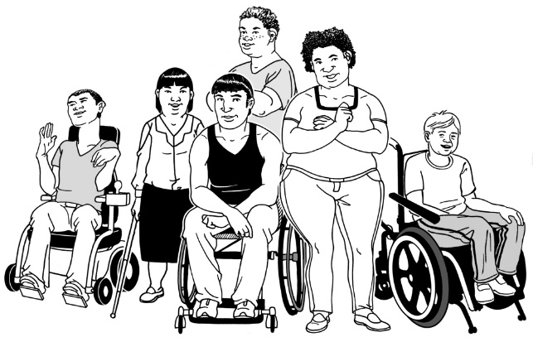
Looking at what Total Mobility is for also includes:
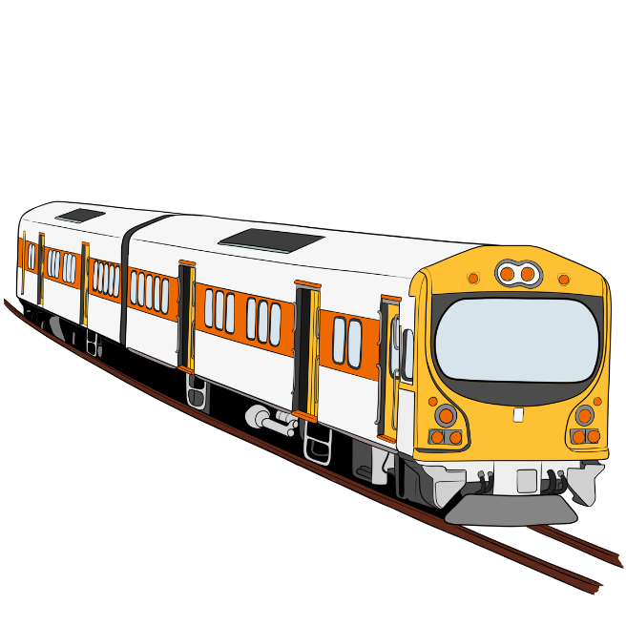
who Total Mobility is meant to support
how Total Mobility works with other kinds of transport
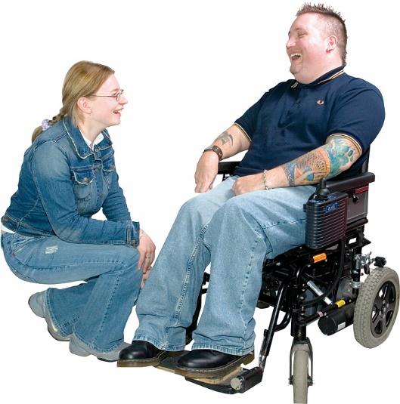
caregivers who support other people to travel.

This part of the review will also look at:
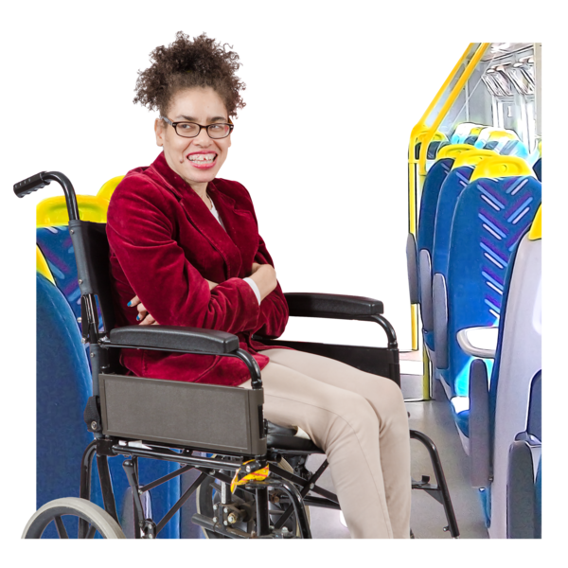
how Total Mobility is used by disabled people
- how the transport needs of disabled people have changed
if Total Mobility is set up in a way that means people can travel:
- independently
- with dignity.

Travelling independently means you get to make your own decisions about travel.

Travelling with dignity means you are treated with respect.

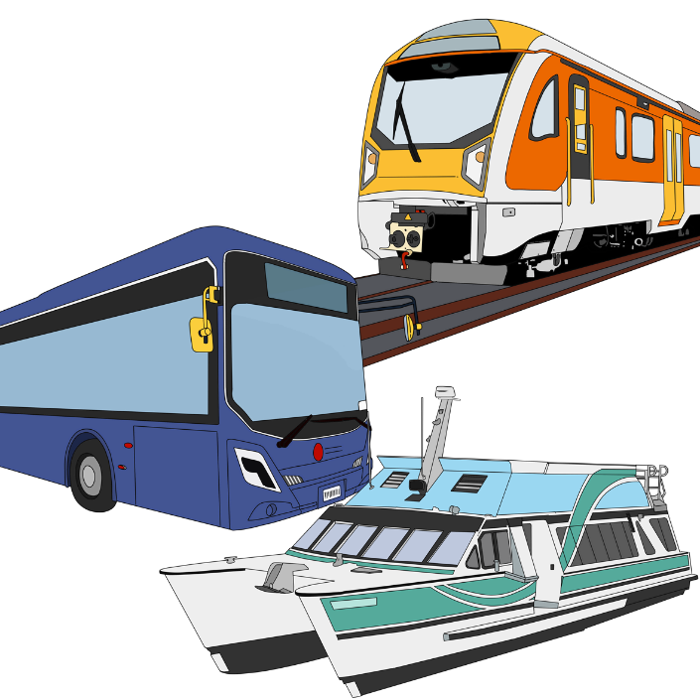
This part of the review will also look at if Total Mobility should:
be used instead of other kinds of transport
work with other kinds of transport.

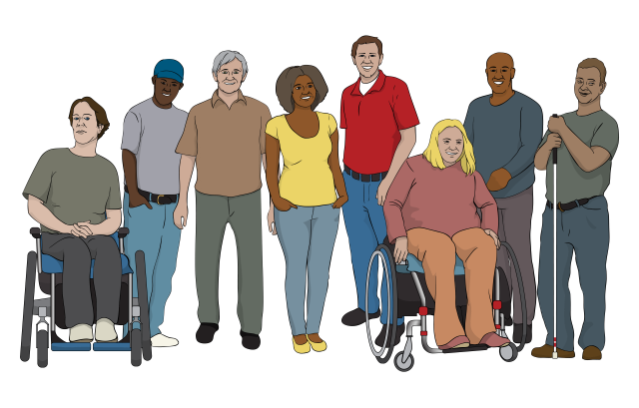
2. How can Total Mobility be more accessible for disabled people?

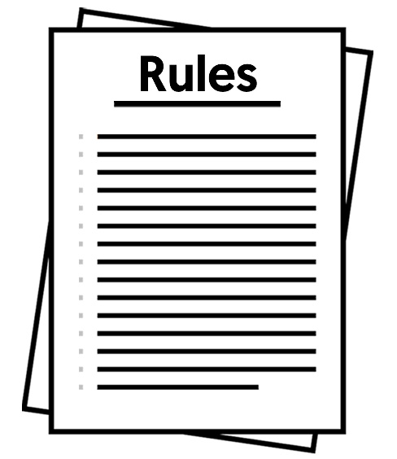
This part of the review will look at:
the rules for who can get Total Mobility discounts
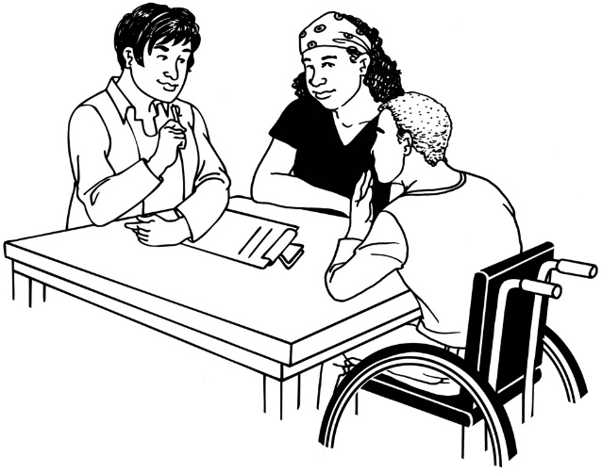
if there are better ways of checking if a person fits the rules to get Total Mobility discounts
if Total Mobility should support all users in the same way
the rules for any money that there might be from the Government for similar support.

This part of the review will also look at:
if users have enough money for Total Mobility services
if there are enough Total Mobility services including wheelchair accessible taxis
what services are like in small towns / rural areas where there are not as many people
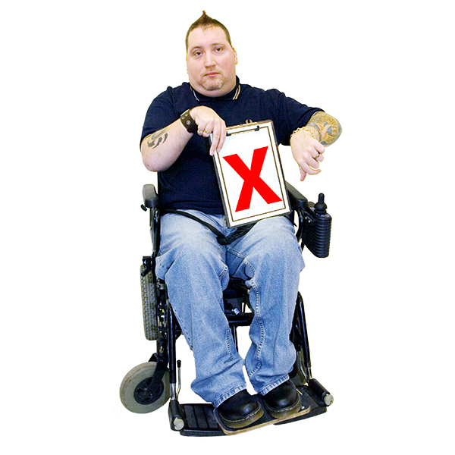
barriers that stop people using Total Mobility
what can be done about those barriers.
Barriers are things that make it harder for disabled people to have a good life.

This part of the review will also look at ways to deal with fraud.

Fraud is when someone lies to get money.

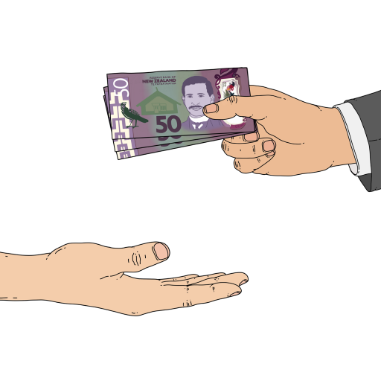
For example:
a taxi driver could pretend they drove someone with a Total Mobility card to get money
someone could pretend to be disabled to get a Total Mobility card.

3. How parts of Total Mobility can work better

This part of the review will look at:
taxis that people can use in their wheelchairs
making sure these taxis are well looked after
- if the computer systems used to run Total Mobility work well.

This part of the review will also look at how Total Mobility operators are trained.

Total Mobility operators are the companies that provide the Total Mobility services.

This part of the review will also look at how information can be better shared between:
operators
councils
Waka Kotahi NZ Transport Agency which looks after transport that is used on land in New Zealand.

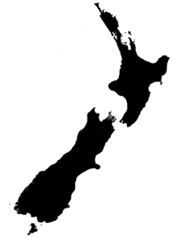
This part of the review will also look at:
how services are different across New Zealand
- rules for who can be a Total Mobility operator
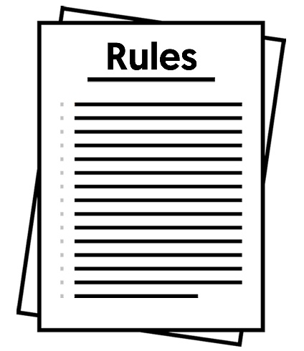
- if the rules make it too hard for people to become Total Mobility operators
- how Total Mobility complaints are handled.

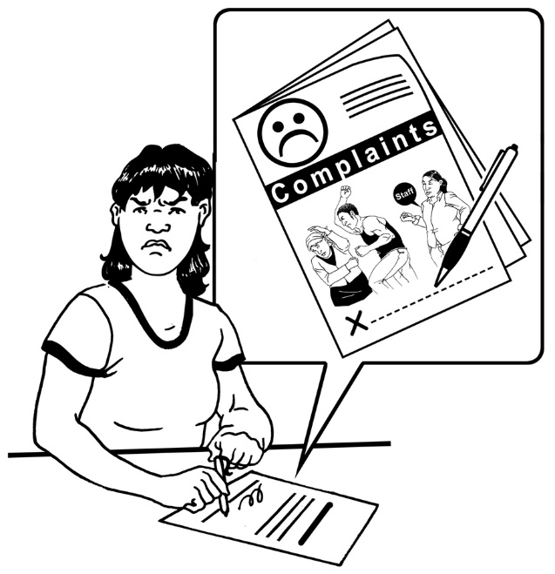
A complaint is when you tell someone:
that you are not happy about something
what needs to be done to make it right.

4. Money to pay for Total Mobility
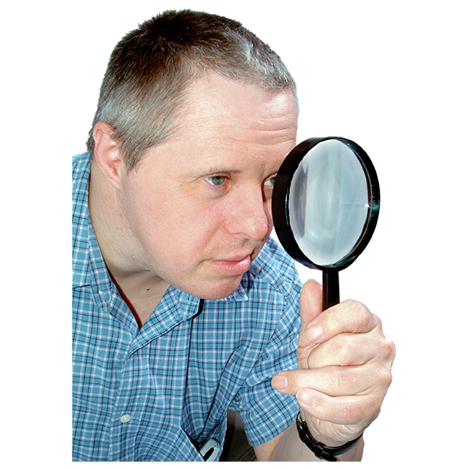

This part of the review will look at:
- how Total Mobility is paid for
- if the ways Total Mobility is paid for are right
- other possible ways of paying for Total Mobility.

How will the review work?

We will work on the review together with:
Waka Kotahi NZ Transport Agency
other people / organisations that Total Mobility is important to.

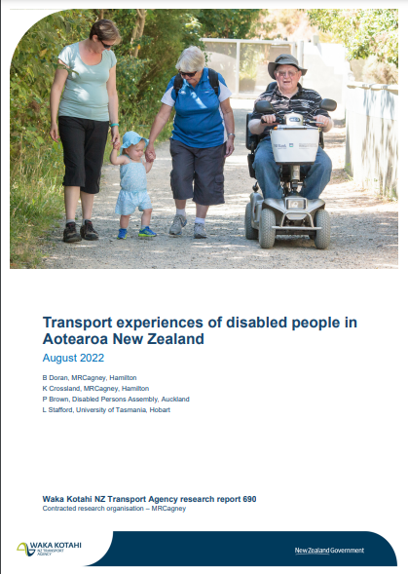
We will learn from a report called:

Transport experiences of disabled people in Aotearoa New Zealand

There is an Easy Read translation of this report at:

www.nzta.govt.nz/resources/
research/reports/690
As part of the review we will talk to people:
from the disability community
who work in areas to do with Total Mobility.

When will the review happen?
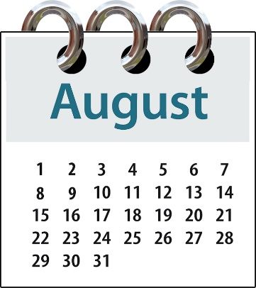
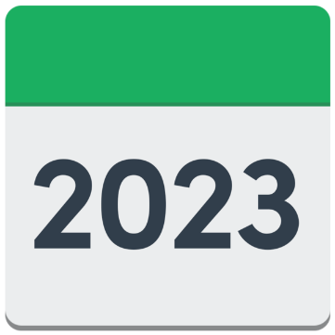
The review started in August 2023.

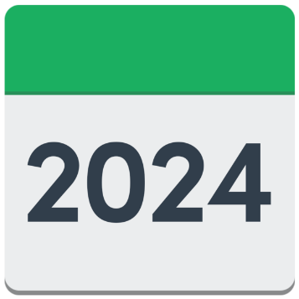
We expect the review to finish late in 2024.

After the review is finished we will share recommendations with the Minister of Transport so they can make decisions about Total Mobility.

Recommendations are ideas for what should happen next.

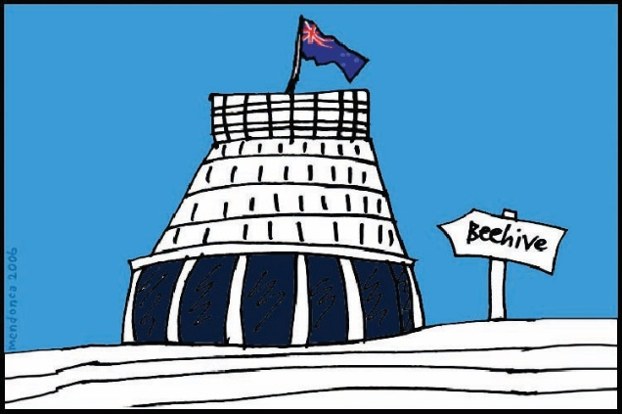
The Minister of Transport is the Member of Parliament who looks after transport.

More information

You can find more about the review at:

tinyurl.com/totalmobilityreview
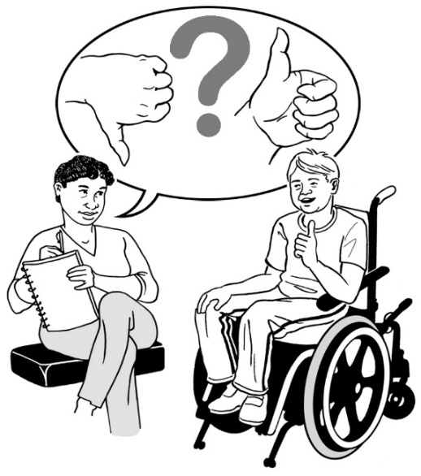

There will be a chance for you to tell us what you think as we work on the review.

You can also email us at:
info@transport.govt.nz

This information has been written by Te Manatū Waka - Ministry of Transport.

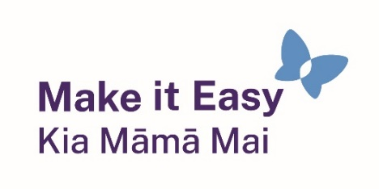
It has been translated into Easy Read by the Make it Easy Kia Māmā Mai service of People First New Zealand Ngā Tāngata Tuatahi.

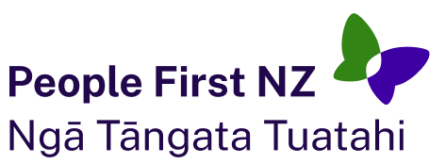
The ideas in this document are not the ideas of People First New Zealand Ngā Tāngata Tuatahi.
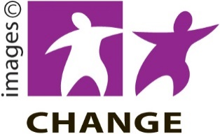
Make it Easy uses images from:

- Changepeople.org

            - Photosymbols.com

- SGC Image Works
- Huriana Kopeke-Te Aho
- T. Wood.
All images used in this Easy Read document are subject to copyright rules and cannot be used without permission.

